1. **Given the provided data, what are three conclusions we can draw about Kickstarter campaigns?**

* >33% campaigns are from theater category, either it’s popular or it might be relatively easy to launch a campaign in theater category; Failure percentage is the highest in food category; music category the success rate is relatively high
* Among the theater category, majority of the campaign is for plays; but the successful rate isn’t highest, documentary seems mostly successful
* Summer time (May-Jul) seems the peak time to submit campaign, but the success rate is low, Feb successful rate is relatively high, might be too many competitors

1. **What are some limitations of this dataset?**

The metric to determine successful isn’t clear, by how much money raised or reach the goal

1. **What are some other possible tables and/or graphs that we could create?**

* We can create following Pie chart showing the percentage of kicks tarter for each country

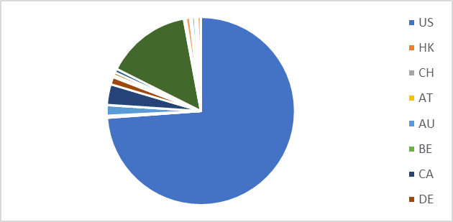

* 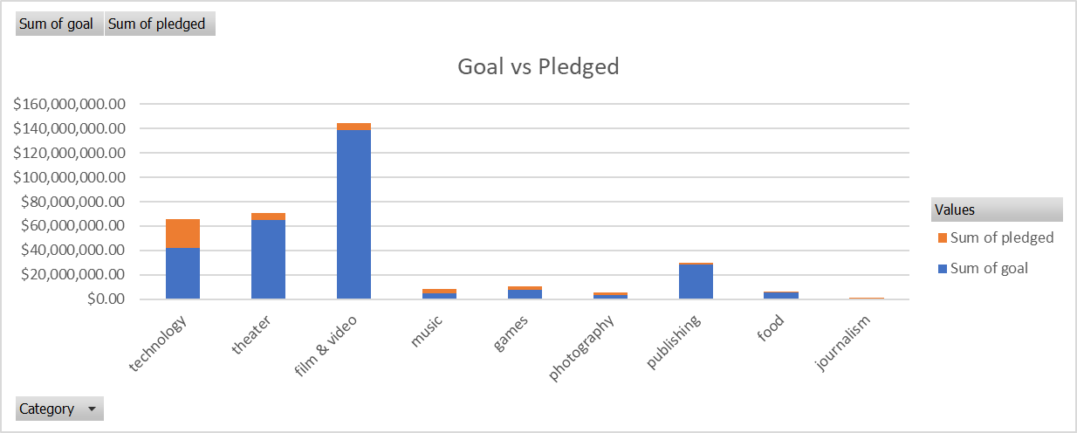Or the bar chart to show the goal vs pledged $ and which category get the most $